**Homework 11 for CS542 - Fall 2022**

**Assigned:** Wednesday, November 15th, 2022  
**Due:** Wednesday, November 29th at 10:00am ET  **NO LATE SUBMISSIONS ACCEPTED!  
Submission:**  CANVAS.  
**Maximum:** 100pts   
**Note:** This homework is to be completed by each student individually. No help besides the textbook should be needed. ***Copying any answers or part of answers from other sources (including the internet and your colleagues) will earn you a grade of zero.***

**Problem 1 (Precedence Graph) [30 Points]**

For each of the following schedules, answer the following:

Q1: Draw the precedence graph for the schedule.

Q2: Is the schedule conflict-serializable? If yes, write down a possible equivalent serial schedule. If not, explain why not.

S1: r1(A), r1(B), r2(A), w3(C), w2(B), w2(C), w1(C)

S2: w3(A), w2(C), r1(A), w1(B), r1(C), r2(A), r4(A), w4(D), r2(D)

S3: Use the table below where the operations at the top take place first.

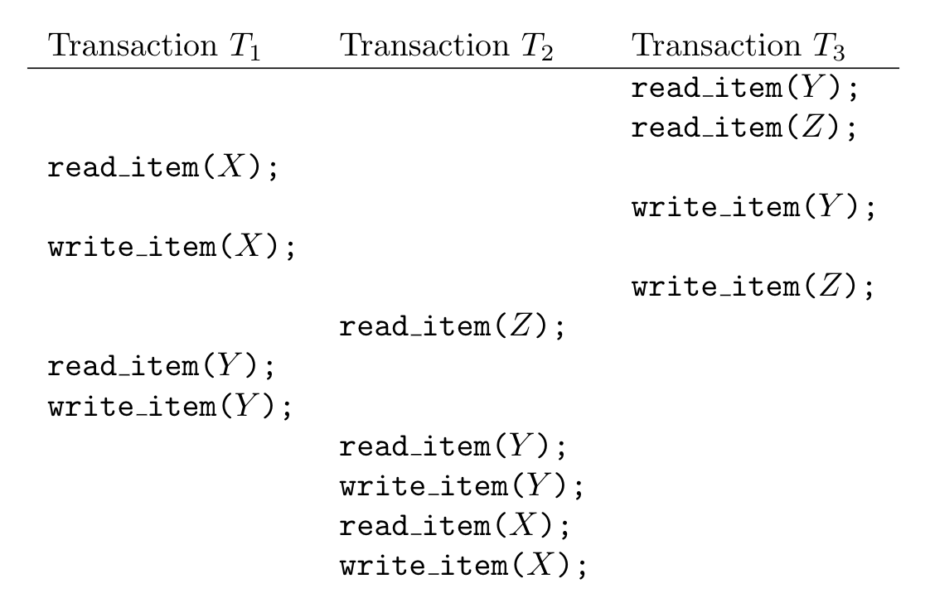

**Problem 2 (Locking Protocol) [30 Points]**

**Q1 [10 Points]:** For each of the following schedules, state whether or not the schedule is legal, and discuss why.

*Remember: A schedule is legal iff:*

*- No two transactions have a lock on the same object, and*

*- No transaction unlocks an object that it does own a lock for*

S1 = l1(A) l1(B) r1(A) w1(B) l2(B) u1(A) u1(B) r2(B) w2(B) u2(B) l3(B) r3(B) u3(B)

S2 = l1(A) r1(A) w1(B) u1(A) u1(B) l2(B) r2(B) w2(B) l3(B) r3(B) u3(B)

**Q2 [20 Points]:** State whether or not Transaction 1 in each of the above schedules is ***Well-Formed***. Discuss why?

**Problem 3 (2 Phase Locking Protocol) [20 Points]**

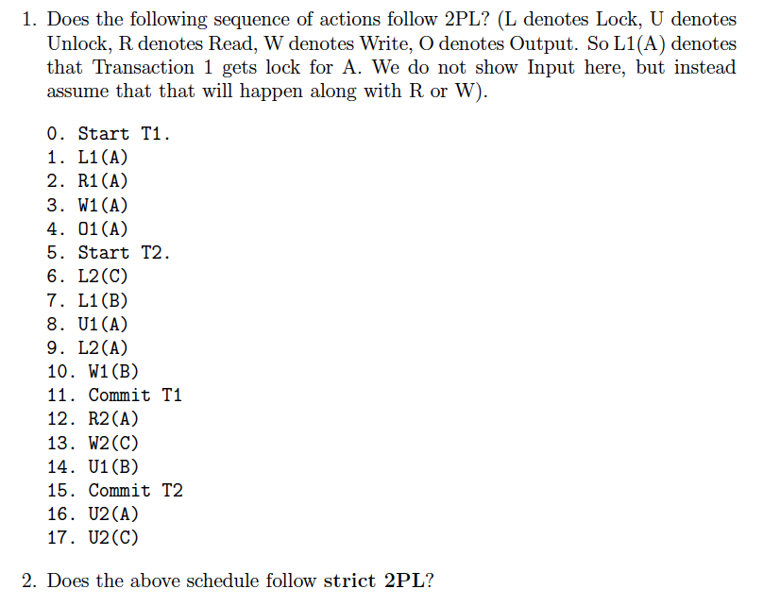

**Problem 4 (Recovery Control) [20 Points]**

The following is a sequence of undo-log records written by two transactions *T* and *U*:

<Start *T*>; <*T*, A, 10>; <Start *U*>; <*U*, B, 20>; <*T*, C, 30>; <*U*, D, 40>; <Commit *U*>; <*T*, E, 50>; <Commit *T*>

Describe the action of the recovery manager, including the changes to both disk and the log if there is a crash and the last log record to appear on disk is:

1. < Start U>
2. <Commit U>
3. <T, E, 50>
4. <Commit T>

**What to Submit**

- Include your answers in one file (.doc, .docx, or .pdf). This is the only file to submit.

**The solutions need to be TYPED.**

- Include your name inside the file.

**Where to Submit**

- In WPI canvas system

**Late Submission Policy**

- No Late submissions allowed.